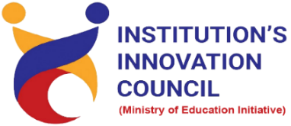
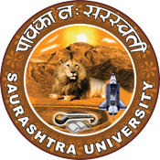
National Technology Day
“India & Technology A Perspective on National Technology Day”
11 May 2023
At
Seminar Hall, Incubation Centre,
Saurashtra University Campus, Rajkot
Contents
Saurashtra University – IIC 2
Event Schedule 2
Event Registration Link 2
Brief about Event 3
Key Points 3
Outcome 3
About the Speaker/Chief Guest 4
Connect Us: 5

Saurashtra University – IIC
The university is dedicated to instruction, research, and extending knowledge to the public (public service). Ministry of Education (MoE), Govt. of India has established ‘MoE’s Innovation Cell (MIC)’ to systematically foster the culture of Innovation among all Higher Education Institutions (HEIs). The primary mandate of MIC is to encourage, inspire and nurture young students by supporting them to work with new ideas and transform them into prototypes while they are informative years. Saurashtra University is one the Organization that have constituted the IIC to foster the vision of MoE and be a part for the promotion and development of innovation ecosystem.

Event Schedule

Event Registration Link

bit.ly/SUSEC-NTDAY

Brief about Event
SU Start-up And Entrepreneurship Council and IIC Saurashtra University are celebrated National Technology Day on "India & Technology: A perspective on National Technology Day" on 11 May, 2023, Thursday at Incubation Centre. Students and faculty of Saurashtra University participated and celebrated National technology day enthusiastically.
National Technology Day is an annual event celebrated in India on 11 May to commemorate the anniversary of the 1998 Pokhran nuclear tests, which showcased India's technological capabilities in the field of nuclear science and technology. The day is dedicated to recognizing and celebrating the achievements of Indian scientists, engineers and researchers who have contributed to the development of technology and innovation in India. It was explained by the speaker.
Sir has highlighted the importance of National Technology Day. He briefed the students that each year a theme is selected for celebration. Also, he motivated the students to come with the sustainable solutions to various problems using the indigenous resources and technology.
The seminar’s objective is to promote scientific temper and inspire the younger generation to pursue careers in STEM (science, technology, engineering, and mathematics) fields. The day also serves as an opportunity to promote and encourage young students to pursue careers in science and technology. The event was very interesting, and will inspire and educate people about the impact of technology on our society.

Key Points
During the session, below mentioned points were discussed:
- Significance of National Technology Day
- History of National Technology Day
- Showcasing innovative projects
- Establish a technology innovation lab or space
- Achievements of India in the field of science and technology.
- FAQs related to National Technology Day

Outcome
As per the event, attendees understood the significance of National Technology Day. Students learned that the day provides a platform to acknowledge the contributions of engineers, scientists, researchers and innovators, who have achieved remarkable achievements in many fields.
Also, as it was related to science & technology and awareness creation, a basic knowledge of technology how-to use, how it works, etc. was made understood by the speaker with examples.

About the Speaker/Chief Guest

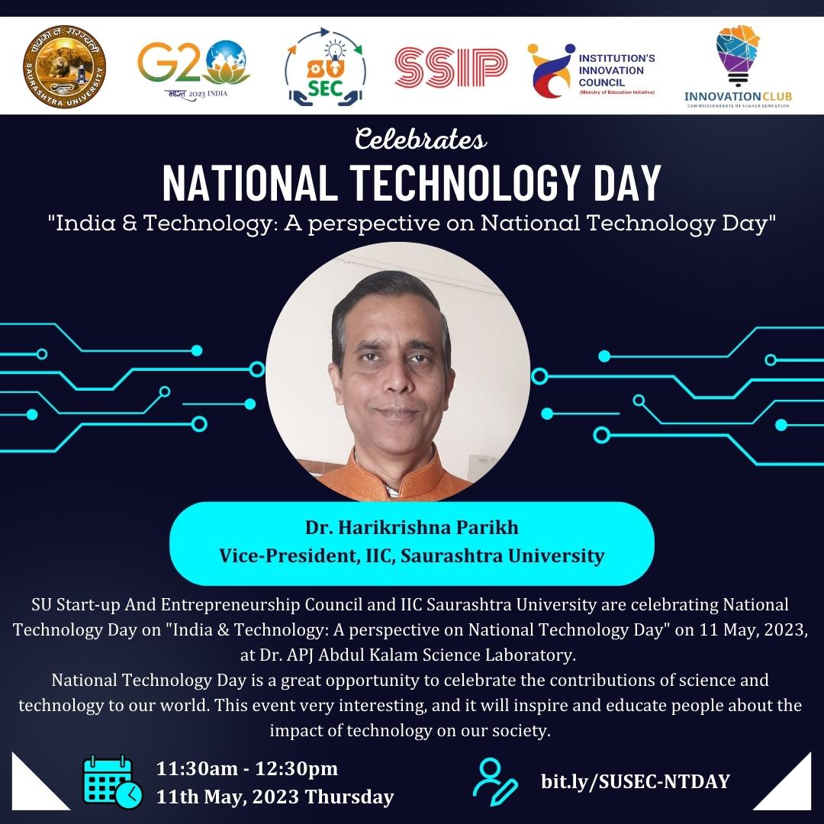

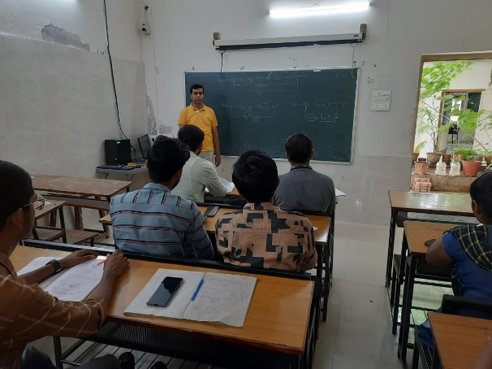
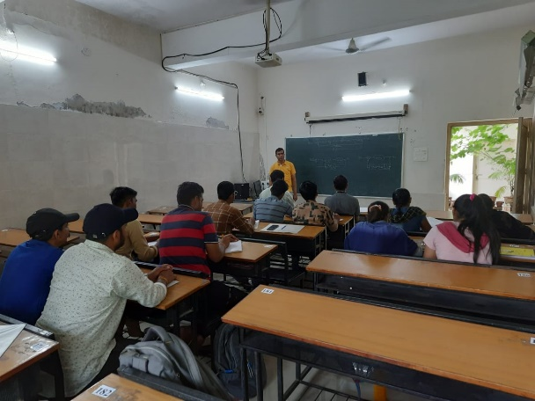

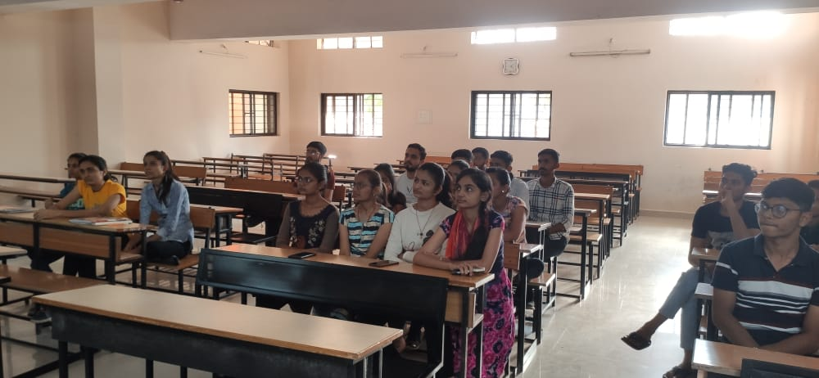

Connect Us:

https://www.linkedin.com/company/susec iic@sauuni.ac.in
https://www.facebook.com/iicsauuni https://bit.ly/SUSECLocation
https://www.instagram.com/susecrajkot https://bit.ly/SUSEC-youtube

